WORKSHEET
SQL (CS)
 | 1 | What are DDL and DML ? Give one command of each.
 | 2 | Which command is used to add new column in existing table?
 | 3 | Which clause is used to search for NULL values in any column?
 | 4 | Which command is used to see information like name of columns,datatype,size etc.?
 | 5 | Which clause is used for pattern matching? What are the 2 main characters used for matching the pattern?
 | 6 | Which clause is used to see the output of query in ascending or descending order?
 | 7 | Which clause is used to eliminate the duplicate rows from output?
 | 8 | What is the minimum number of column required in MySQL to create table?
 | 9 | Which command is used to remove the table from database?
 | 10 | Which command is used to add new record in table?
 | 11 | Which option of ORDER BY clause is used to arrange the output in descending order?
 | 12 | Which command is used to change the existing information of table?
 | 13 | Rajisa database programmer, He has to write the query from EMPLOYEE table to search for the employee whose name begins from letter„R‟,for this he has written the query as: SELECT* FROM EMPLOYEE WHERE NAME=‟R%‟;  But the query is not producing the correct output, help Raj and correct the query so that he gets the desired output.
 | 14 | Raj is a database programmer, He has to write the query from EMPLOYEE table to search for the employee who are not getting any commission, for this he has written the query as: SELECT * FROM EMPLOYEE WHERE commission=null;  But the query is not producing the correct output, help Raj and correct the query so that he gets the desired output.
 | 15 | Rajisa database programmer,has to write the query from EMPLOYEE table to search for the employee who are working in „Sales‟ or „IT‟ department, for this he has written the query as: SELECT*FROMEMPLOYEEWHEREdepartment=‟Sales‟or„IT‟;  But the query is not producing the correct output, help Raj and correct the query so that he gets the desired output.

TEACHER_CODE | TEACHER_NAME | DOJ
T001 | ANAND | 2001-01-30
T002 | AMIT | 2007-09-05
T003 | ANKIT | 2007-09-20
T004 | BALBIR | 2010-02-15
T005 | JASBIR | 2011-01-20
T006 | KULBIR | 2008-07-11

 | 16 | Thefollowingqueryisproducinganerror.Identifytheerrorandalsowritethecorrectquery. SELECT * FROM EMP ORDER BY NAME WHERE SALARY>=5000;
 | Ans. | AsperMySQL,ORDERBYmustbethelastclauseinSQLQUERY,andinthisqueryORDER BY is used before WHERE which is wrong, the correct query will be:  SELECT*FROMEMPWHERESALARY>=5000ORDERBYNAME;
 | 17 | IfTableSalescontains5recordsandRajexecutedthefollowingqueries;findouttheoutput of both the query.  - Select100+200fromdual;  - Select100+200fromSales;
 | Ans. | - 300  - 300  300  300  300  300
 | 18 | What isthedifferencebetween Equi-Joinand NaturalJoin?
 | Ans. | InEquijoinwecomparevalueofanycolumnfromtwotablesanditwillreturnmatching rows.InEqui-joincommoncolumnappearstwiceinoutputbecausewefetchusing(*)notby specifying column name. for e.g.  InEqui-joinitisnotmandatorytohavesamenameforcolumntocompareofbothtable Innaturaljoinalsothematchingrowswillreturn.Innaturaljoincolumnwillappearonly  once in output. Then name of column must be same in both table if we are performing natural join using the clause NATURAL JOIN.
 | 19 | ObservethegivenTableTEACHERandgivetheoutputofquestion(i)and(ii)  - SELECTTEACHER_NAME,DOJFROMTEACHERWHERETEACHER_NAMELIKE„%I%‟  - SELECT*FROMTEACHERWHEREDOJLIKE„%-09-%‟;
 | Ans | (i)  TEACHER_NAME DOJ  -------------------------------------------------------  AMIT 2007-09-05  ANKIT 2007-09-20  BALBIR 2010-02-15  JASBIR 2011-01-20  KULBIR 2008-07-11  (ii)  TEACHER_CODE TEACHER_NAME DOJ  ----------------------------------------------------------------------  T002 AMIT 2007-09-05  T003 ANKIT 2007-09-20
 | 20 | WhichSQLfunctionisusedtogettheaveragevalueofanycolumn?
 | Ans. | AVG()
 | 21 | WhatisthedifferencebetweenCOUNT()andCOUNT(*)function
 | Ans. | COUNT()functionwillcountnumberofvaluesinanycolumnexcludingtheNULLs  COUNT(*)willcountnumberofrowsinqueryoutputincludingNULLs
 | 22 | Whatis thefullformofSQL?
 | Ans. | StructuredQueryLanguage

 | 23 | Querytodeleteallrecordoftablewithoutdeletingthetable:  - DELETETABLETABLE_NAME  - DELETEFROMTABLE_NAME  - DROPTABLETABLE_NAME  - DELETETABLEFROMTABLE_NAME
 | Ans. | b.DELETEFROMTABLE_NAME
 | 24 | IdentifythewrongstatementaboutUPDATEcommand  - If WHEREclauseismissingalltherecordintablewillbeupdated  - OnlyonerecordcanbeupdatedatatimeusingWHEREclause  - MultiplerecordscanbeupdatedatatimeusingWHEREclause  - Noneoftheabove
 | Ans. | b.OnlyonerecordcanbeupdatedatatimeusingWHEREclause
 | 25 | Identifythecorrectstatement(s)todropacolumnfromtable  - DELETECOLUMNCOLUMN_NAME  - DROPCOLUMNCOLUMN_NAME  - ALTERTABLETABLE_NAMEDROPCOLUMNCOLUMN_NAME  - ALTERTABLETABLE_NAMEDROPCOLUMN_NAME
 | Ans. | - ALTERTABLETABLE_NAMEDROPCOLUMNCOLUMN_NAME  - ALTERTABLETABLE_NAMEDROPCOLUMN_NAME
 | 26 | Suppose a table BOOK contain columns (BNO, BNAME, AUTHOR, PUBLISHER), Raj is assigned a task to see the list of publishers, when he executed the query as:  SELECTPUBLISHERFROMBOOK;  He noticed that the same publisher name is repeated in query output. What could be possible solution to get publisher name uniquely? Rewrite the following query to fetch unique publisher names from table.
 | Ans. | SolutionistouseDISTINCTclause.  CorrectQuery:SELECTDISTINCTPUBLISHERFROMBOOK;
 | 27 | HOTS  Consider a database table T containing two columns X and Y each of type integer. After the creation of the table, one record (X=1, Y=1) is inserted in the table.  Let MX and MY denote the respective maximum values of X and Y among all records in the table at any point in time. Using MX and MY, new records are inserted in the table 128 times with X and Y values being MX+1, 2*MY+1 respectively. It may be noted that each time aftertheinsertion, values of MX andMYchange. Whatwillbetheoutput of thefollowing SQL query after the steps mentioned above are carried out?  SELECTYFROMTWHEREX=7  A.127  B.255  C.129  D.257
 | Ans. | A.127
 | 28 | WhichSQLfunctionisusedtofindthehighestandlowestvalueof numericanddatetype  column?
 | Ans. | MAX()andMIN()
 | 29 | WhatisthedefaultorderofsortingusingORDERBY?
 | Ans. | Ascending
 | 30 | WhatisthedifferencebetweenCHARandVARCHAR?
 | Ans. | CHARisfixedlengthdatatype.Forexampleifthecolumn„name‟ifofCHAR(20)thenallname willoccupy20bytesforeachnameirrespectiveofactualdata.  VARCHARisvariablelengthdatatypei.e.itwilloccupysizeaccordingtheactuallengthof data

 | 31 | WriteSQLqueriesfor(i)to(iv)andfindoutputs forSQLqueries(v)to(viii)whicharebasedontables  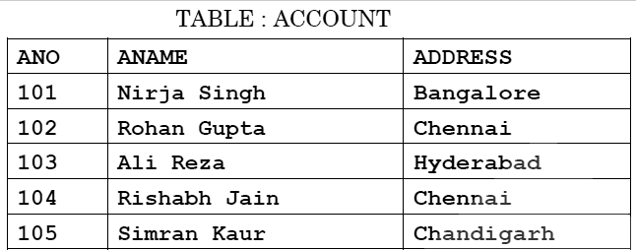  TABLE:TRANSACT  TRNO ANO AMOUNT TYPE DOT  T001 101 2500 Withdraw 2017-12-21  T002 103 3000 Deposit 2017-06-01  T003 102 2000 Withdraw 2017-05-12  T004 103 1000 Deposit 2017-10-22  T005 102 12000 Deposit 2017-11-06  - TodisplaydetailsofalltransactionsofTYPEWithdrawfromTRANSACTtable  - TodisplayANOandAMOUNTofallDepositandWithdrawalsdoneinmonthof  „May‟2017 fromtableTRANSACT  - To display first dateof transaction (DOT) from tableTRANSACT for Account havingANO as 102  - To display ANO, ANAME, AMOUNT and DOT of those persons from ACCOUNT and TRANSACT table who have done transaction less than or equal to 3000  - SELECTANO,ANAMEFROMACCOUNT  WHEREADDRESSNOTIN('CHENNAI','BANGALORE');  - SELECTDISTINCTANOFROMTRANSACT  - SELECTANO,COUNT(*),MIN(AMOUNT)FROMTRANSACT GROUP BY ANO HAVING COUNT(*)> 1  - SELECT COUNT(*), SUM(AMOUNT) FROM TRANSACTWHERE DOT <= '2017-10-01'
 | Ans. | - Select*fromTRANSACTwhereTYPE=’Withdraw’;
 |  | (ii) SelectANO,AMOUNTfromTRANSACTwhereDOTlike‘%-05-%’;
 |  | (iii) SelectMIN(DOT)fromTRANSACTwhereANO=102
 |  | (iv) SelectANO,T.ANO,ANAME,AMOUNTfromACCOUNTA,TRANSACTTwhereA.ANO=T.ANOand
 |  | AMOUNT<=3000;
 |  | (v)
 |  | ANO ANAME
 |  | 103 AliReza
 |  | 105 SimranKaur
 |  | (vi)
 |  | ANO
 |  | 101
 |  | 103
 |  | 102
 |  | 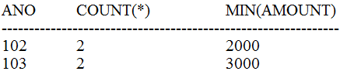(vii)
 |  | 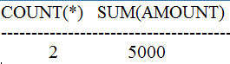(viii)

 | 32 | ConsiderthefollowingtablesEMPandSALGRADE,writethequeryfor(i)to(vi)andoutput
 |  | for(vii)to(x)
 |  | TABLE:EMPLOYEE
 |  | ECODE NAME DESIG SGRADE DOJ DOB
 |  | 101 Vikrant Executive S03 2003-03-23 1980-01-13
 |  | 102 Ravi Head-IT S02 2010-02-12 1987-07-22
 |  | 103 JohnCena Receptionist S03 2009-06-24 1983-02-24
 |  | 105 AzharAnsari GM S02 2009-08-11 1984-03-03
 |  | 108 PriyamSen CEO S01 2004-12-29 1982-01-19
 |  | TABLE:SALGRADE
 |  | SGRADE SALARY HRA
 |  | S01 56000 18000
 |  | S02 32000 12000
 |  | S03 24000 8000
 |  | (i) TodisplaydetailsofallemployeeindescendingorderoftheirDOJ
 |  | (ii) TodisplayNAMEANDDESIGofthoseemployeeswhosesgradeiseither„S02‟or
 |  | „S03‟
 |  | (iii) TodisplayNAME,DESIG,SGRADEofthoseemployeewhojoinedintheyear2009
 |  | (iv) To display all SGRADE, ANNUAL_SALARY from table SALGRADE [where
 |  | ANNUAL_SALARY=SALARY*12]
 |  | (v) TodisplaynumberofemployeeworkingineachSALGRADEfromtableEMPLOYEE
 |  | (vi) TodisplayNAME,DESIG,SALARY,HRAfromtablesEMPLOYEEandSALGRADE
 |  | whereSALARYislessthan50000
 |  | (vii) SelectMIN(DOJ),MAX(DOB)fromemployee;
 |  | (viii) SelectSGrade,Salary+HRAfromSalGradewhereSgrade=‟S02‟
 |  | (ix) Selectcount(distinctsgrade)fromemployee
 |  | (x) Selectsum(salary),avg(salary)fromsalgrade
 | Ans | - SELECT*FROMEMPLOYEEORDERBYDOJDESC  - SELECTNAME,DESIGFROMEMPLOYEEWHERESGRADEIN('S02','S03')
 |  | OR
 |  | SELECTNAME,DESIGFROMEMPLOYEEWHERESGRADE='S02'OR
 |  | SGRADE='S03'
 |  | (iii) SELECTNAME,DESIG,SGRADEFROMEMPLOYEEWHEREDOJLIKE'2009%'
 |  | (iv) SELECTSGRADE,SALARY*12ANNUAL_SALARYFROMSALGRADE
 |  | (v) SELECTSGRADE,COUNT(*)FROMEMPLOYEEGROUPBYSGRADE
 |  | (vi) SELECTNAME,DESIG,SALARY,HRA FROMEMPLOYEEE,SALGRADES WHERE
 |  | E.SGRADE=S.SGRADEANDSALARY<=50000
 |  | (vii) MIN(DOJ) MAX(DOB)
 |  | 2003-03-23 1987-07-22
 |  | (viii) SGRADESALARY+HRA
 |  | S02 44000
 |  | (ix) COUNT(*)
 |  | 3
 |  | (x) SUM(SALARY) AVG(SALARY)
 |  | 112000 37333.33

 | 33 | 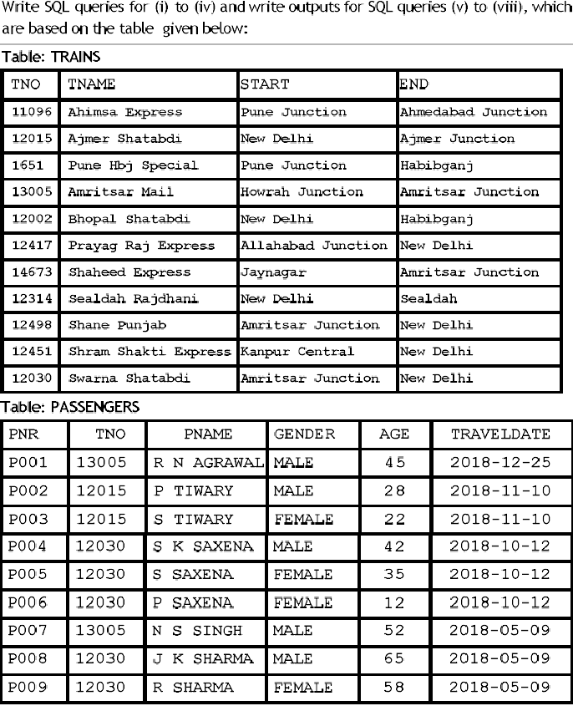  - TodisplaydetailsofallTrainswhichstartsfromNewDelhi  - To display PNR, PNAME, GENDER and AGE of all passengers whose AGE is below 50  - TodisplaytotalnumbersofMALEandFEMALEpassengers  - TodisplayrecordsofallpassengerstravellingintrainswhoseTNOis12015  - SELECT MAX(TRAVELDATE),MIN(TRAVELDATE) FROM PASSENGERS WHERE GENDER=‟FEMALE‟;  - SELECTEND,COUNT(*)FROMTRAINSGROUPBYENDHAVINGCOUNT(*)>1;  - SELECTDISTINCTTRAVELDATEFROMPASSENGERS;  - SELECT TNAME, PNAME FROM TRAINS T, PASSENGERS P WHERE T.TNO=P.TNO AND AGE BETWEEN 50 AND 60

 | Ans | - SELECT*FROMTRAINSWHERESTART='NEWDELHI'  - SELECTPNR,PNAME,GENDER,AGEFROMPASSENGERWHEREAGE<50  - SELECTGENDER,COUNT(*)FROMPASSENGERSGROUPBYGENDER  - SELECT*FROMPASSENGERSWHERETNO=12015  - MAX(TRAVELDATE) MIN(TRAVELDATE)  2018-11-10 2018-05-09  - END COUNT(*)  HABIBGANJ 2  AMRITSARJUNCTION 2  NEWDELHI 4  - TRAVELDATE  2018-12-25  2018-11-10  2018-10-12  2018-05-09  - TNAME PNAME  AJMERSHATABDI PTIWARY  AJMERSHATABDI S TIWARY  AMRITSARMAIL RNAGRAWAL  AMRITSAR MAIL N S SINGH SWARNA SHATABDI S K SAXENA SWARNA SHATABDI S SAXENA SWARNASHATABDI J K SHARMA  SWARNASHATABDI RSHARMA
 | 34 | ConsiderthetableSHOPPEandACCESSORIES,writethequeryfor(i)to(v)andoutputfor  (vi)to(x)  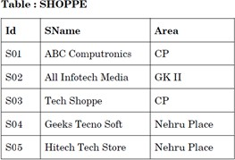

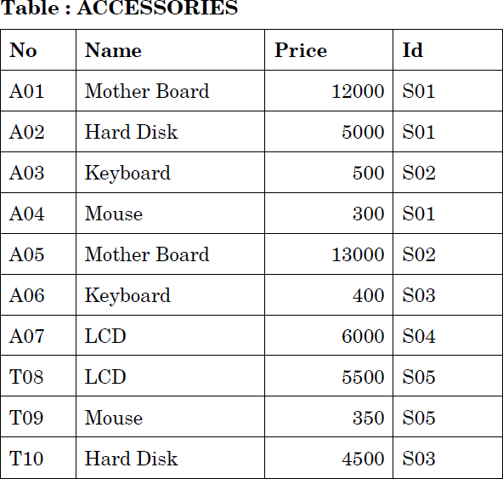

- TodisplayNameandPriceofalltheAccessoriesindescendingorderoftheirPrice
- TodisplayIdandSnameofalltheShoppelocationin„NehruPlace‟
- TodisplayName,MinimumandMaximumPriceofeachName fromACCESSORIES table
- TodisplayName,PriceofallAccessoriesandtheirrespectiveSNamefromtableSHOPPE andACCESSORIESwherePriceis5000ormore.
- Todisplayalldetailsofaccessorieswherenamecontainsword„Board‟;
- SELECTDISTINCTNAMEFROMACCESSORIESWHEREPRICE>5000;
- SELECTAREA,COUNT(*)FROMSHOPPEGROUPBYAREA;
- SELECTAVG(PRICE),MAX(PRICE)FROMACCESSORIESWHEREPRICE>=10000;
- SELECTNAME,PRICE*.05DISCOUNTFROMACCESSORIESWHEREIDIN(„S02‟,‟S03‟)
- SELECT*FROMSHOPPES,ACCESSORIESAWHERES.ID=A.IDANDPRICE>=10000;
 | Ans | - SELECTNAME,PRICEFROMACCESSORIESORDERBYPRICEDESC  - SELECTID,SNAMEFROMSHOPPEWHEREAREA='NEHRUPLACE'  - SELECTNAME,MIN(PRICE),MAX(PRICE)FROMACCESSORIESGROUPBYNAME  - SELECT NAME,PRICE,SNAME FROM SHOPPE S, ACCESSORIES A WHERE S.ID=A.ID AND PRICE>=5000  - SELECT*FROMACCESSORIESWHERENAMELIKE„%BOARD%‟  - NAME  MotherBoard LCD  - AREA COUNT(*)  CP 2  GKII 1  NehruPlace 2  - AVG(PRICE) MAX(PRICE)  12500 13000  - NAME DISCOUNT  Keyboard 25  MotherBoard 650  Keyboard 20  HardDisk 225  - ID SNAME AREA NO NAME PRICE ID  S01 ABC Computronics CP A01 Mother board 12000 S01 S02AllInfotechmedia GKII A05 Motherboard 13000 S02

 | 35 | - Inadatabasetherearetwotables:WriteMYSQLqueriesfor(i)to(iii)  Table:Item  ICode IName Price Color VCode  S001 MobilePhones 30000 Silver P01  S002 Refrigerator 20000 Cherry P02  S003 TV 45000 Black P03  S004 Washing Machine 12000 White P04 S005 Air Conditioner 50000 White P05 Table : Vendor  VCode VName  P01 Rahul  P02 Mukesh  P03 Rohan  P04 Kapil  - TodisplayICode,INameandVNameofallthevendors,whomanufacture“Refrigerator”.  - TodisplayIName,ICode,VNameandpriceofalltheproductswhoseprice>=23000  - TodisplayVnameandINamemanufacturedbyvendorwhosecodeis“P04”.
 | Ans | - SelectICode,IName,VNamefromItemI,VendorVwhereI.Vcode=V.VCodeand IName='Refrigerator'  - Select IName, ICode,VName from Item I,Vendor Vwhere I.Vcode=V.VCode and Price>=23000  - SelectVName,INamefromItemI,VendorVwhereI.Vcode=V.VCodeandI.VCode='P04'
- Whatwillbetheoutputofthefollowing-
  - SelectRound(1449.58,-2);
  - SelectRound(7.5789,3); IPONLY
  - SelectSubstr(“HelloRahul”,3,8);
  - SelectDayofmonth(“2020-10-24”);
 | And | 1.1400  2.7.579  - ellohRah  - 24
 | 36 | In a database there are two tables : Write MYSQL queries for (i) to (vi) Table : Doctors  DocID DocName Department NoofOpdDays  - JKMishra Ortho 3  - Maheshtripathi ENT 4  - RaviKumar Neuro 5  - MukeshJain Physio 3  Table: Patients  PatNo PatName Department DocId  - Payal ENT 102  - Naveen Ortho 101  - Rakesh Neuro 103  - Atul Physio 104  - TodisplayPatNo,PatNameandcorrespondingDocNameforeachpatient.  - TodisplaythelistofalldoctorswhoseNoofOpdDaysaremorethan3  - To display DocName, Department,PatName and DocId from both the tables where DocID is either 101 or 103  - To displaytotalnoof differentdepartmentsfrom Patientstable.

VisitorID | VisitorName | Gender | ComingFrom | AmountPaid
1 | Suman | F | Kanpur | 2500
2 | Indu | F | Lucknow | 3000
3 | Rachana | F | Haryana | 2000
4 | Vikram | M | Kanpur | 4000
5 | Rajesh | M | Kanpur | 3000
6 | Suresh | M | Allahabad | 3600
7 | Dinesh | M | Lucknow
8 | Shikha | F | Varanasi | 5000

 | Ans. | - selectPatNo,PatName,DocNamefromDoctorsD,PatientsPwhereD.DocID=  P.DocID  - select*fromDoctorswhereNoofOpdDays>3  - SelectDocID,DocName,Department,PatNamefromDoctorD,PatientPwhere D.DocId = P.DocId and DocId in (101,103)  - selectcount(distinctDepartment)fromPatient
 | 37 | Given the Table “BANK” with records, Give the output of given queries–NAME  SACHIN RAMESH DINESH VIKAASH RAJU AMRITESH  - Select*fromBANKwhereNameLike„%ES%‟;  - Select*fromBANKwhereNameLike„ SH‟
 | Ans | - RAMESH DINESH AMRITESH  - RAMESH DINESH
 | 38 | RajeshadatabasedeveloperatStoreIndiawantstosearchtherecordofthoseemployees whosenamestartsfrom„R‟andtheyhavenotallottedanyproject,forthishehaswritten the following query-  Select*fromEmployeewhereName=‘R%’andProject=Null;  Butthequeryisnotproducingthecorrectoutput.Rewritethequeryaftercorrectingthe errors
 | Ans | Select*fromEmployeewhereNamelike„R%‟andProjectisnull
 | 39 | ConsideringtheVisitortabledata,writethequeryfor(i)to(iv)andoutputfor(v)to(viii)  - WriteaquerytodisplayVisitorName,ComingFromdetailsofFemaleVisitorswith Amount Paid more than 3000  - Writeaquerytodisplayallcomingfromlocationuniquely  - Write a query to insert the following values- 7, „Shilpa‟,‟F‟,‟Lucknow‟,3000  - WriteaquerytodisplayalldetailsofvisitorsinorderoftheirAmountPaidfrom highest to lowest  - SelectVisitorNamefromVisitorwhereGender=‟M‟;  - SelectAmountPaid+200fromVisitorwhereVisitorID=6;  - SelectSum(AmountPaid)fromVisitorwherecomingFrom=‟Kanpur‟;  - SelectCount(VisitorName)fromVisitorwhereAmountPaidisNULL;

 | Ans. | (i) Select VisitorName,ComingFrom from Visitor |  |  |  | where | Gender='F' | and
 |  | AmountPaid>3000
 |  | (ii) SelectdistinctComingFromfromVisitor
 |  | (iii) insertintovisitorvalues(7,'Shilpa','F','Lucknow',3000)
 |  | (iv) Select*fromvisitororderbyAmountPaiddesc
 |  | (v) VisitorName
 |  | Vikram
 |  | Rajesh
 |  | Suresh
 |  | Dinesh
 |  | (vi) AmountPaid+200
 |  | 3800
 |  | (vii) Sum(AmountPaid)
 |  | 9500
 |  | (viii) Count(VisitorName)
 |  | 1
 | 40 | WriteaMySQLquerytocreatethegiventable(MEMBER)
 |  |  | Columnname | Datatype | Size
 |  |  | ID | Char | 6
 |  |  | Name | Varchar | 30
 |  |  | Fee | Int | 10
 |  |  | DOJ | Date
 | Ans. | createtablemember(idchar(6),namevarchar(30),feeint(10),dojdate)
 | 41 | WhatistheDifferencebetweenALTERTablecommandandUPDATEcommand?
 | Ans. | ALTER is DDL command and is used for modifying the schema of table like adding new column, modifying column definition, dropping column. UPDATE is DML command and isusedformodifyingtheexistingdataoftablelikechangingthemobilenumber,changingthe  salaryetc.
 | 42 | - Sanjaywasdeletingtherecordofempno=1234,butatthetimeofexecutionofcommandhe forgottoaddconditionempno=1234,whatwillbetheeffectofdeletecommandinthiscase?  - Sameerisexecutingthequerytofetchtherecordsofemployeewhoaregettingsalary between 4000 to 8000, he executed the query as -  Select * from employee where salary between 4000 to 8000; Butheisnotgettingthecorrectoutput,Rewritethecorrectquery.
 | Ans. | - Ifwhere clauseismissingwithDELETEthenitwilldeletealltherecordoftable.  - Select*fromemployeewheresalarybetween40000and80000
 | 43 | WriteMYSQL command toseethelistoftables in currentdatabase
 | Ans. | Showtables
 | 44 | Sunil decides to delete a PhoneNo column from a MySQL Table (student) after insert the data into the table. Write the command to delete that particular column in student table.
 | Ans. | ALTERTABLEstudentdropPhoneNo
 | 45 | AtableEmployeecontains5Rowsand4ColumnsandanothertablePROJECTcontains5 Rowsand3Columns.HowmanyrowsandcolumnswillbethereifweobtainCartesian  productofthesetwotables?
 | Ans. | Rows=5x5=25  Columns=4+3=7
 | 46 | Ranjeetcreatedatablenamedstudent,Hewantstoseethosestudentswhosenameending with p. He wrote a query- SELECT * FROM student WHERE name=”p%”;  Butthequeryisnotproducingthedesiredoutput,HelpRanjeettorunthequerybyremoving the errors from the query and rewriting it.

EMPNO | ENAME | DEPT | SALARY | COMM
1 | ANKIT | HR | 20000 | 1200
2 | SUJEET | ACCOUNTS | 24000
3 | VIJAY | HR | 28000 | 2000
4 | NITIN | SALES | 18000 | 3000
5 | VIKRAM | SALES | 22000 | 1700

 | Ans | SELECT*FROMstudentWHEREnameLIE”p%”;
 | 47 | ConsiderthefollowingEMPLOYEEtablewriteMYSQLcommandfor(i)to(iv)andOutputsfor  (v)to(viii)  - Todisplaythenameofemployeesstartingfrom„V‟inascendingorderoftheirsalary  - TodisplaythedetailsofallSALESdeptemployeewhoareearningsalarymorethan 20000  - Tocountdistinctdepartmentfromthetable  - ChangethesalaryofNITINfrom18000to20000  - ToinsertanewrowinthetableEmployee  „6‟,„SUMIT‟,‟HR‟,40000,2000  - SelectAVG(COMM)fromEmployee  - SelectENAME,DEPTfromEmployeewhereDeptin(„HR‟,‟ACCOUNTS‟)  - SelectENAME,SALARY+100NEWSALfromEmployee
 | Ans. | - selectenamefromemployeewhereenamelike'V%'orderbysalary;  - Select*fromemployeewheredept='Sales'andsalary>20000;  - selectcount(distinctdept)fromemployee;  - updateemployeesetsalary=20000whereename='NITIN';  - insertintoemployeevalues(6,'SUMIT','HR',40000,2000)  - 1980 (includingrecordinsertedin(v))  - ENAME DEPT  ANKIT HRSUJEET ACCOUNTS VIJAY HR  - ENAME NEWSAL  ANKIT 20100  SUJEET 24100  VIJAY 28100  NITIN 20100  VIKRAM 22100  SUMIT 40100
 | 48 | WriteMYSQLcommandtocreatethe tableENQUIRYincludingits constraints  Table: ENQUIRY
 |  |  | Nameofcolumn | Type |  | Size |  | Constraints
 |  |  | visitorID | Decimal |  | 4 |  | Primarykey
 |  |  | visitorName | Varchar |  | 20
 |  |  | visitorMobile | Char |  | 10 |  | Notnull
 |  |  | visitorAddress | Varchar |  | 40
 | Ans. | createtableENQUIRY(visitorIDdecimal(4)primarykey,visitorNamevarchar(20)visitorMobile  char(10)notnull,visitorAddressvarchar(40))
 | 49 | Inadatabase thereare twotables:  Table: Doctor
 |  |  | DocID |  | DocName |  | Specialist
 |  |  | D001 |  | VimalJha |  | Cardio
 |  |  | D002 |  | SunilBawra |  | Ortho
 |  |  | D003 |  | MukulBarman |  | Surgeon
 |  |  | D004 |  | NiteshSolanki |  | Skin

Table: Patient
PatID PatName DateAdm DocID
P001 Kapil 2013-10-10 D002
P002 Susheel 2013-09-01 D001
P003 Wasim 2013-10-15 D002
P004 Sanjay 2013-10-12 D003
P005 Jai 2013-10-17 D003

WritetheMySQLqueriesforthefollowing:
- TodisplayPatID,PatName,andcorrespondingDocNameof„Cardio‟and„Ortho‟ patient
- TodisplayDocName,PatNameofthosepatientwhoareadmittedbefore15-Oct- 2013
 | Ans. | - select PatID, PatName,DocName from Doctor D, Patient P where D.DocID = P.DocID and specialist in ('Cardio','Orto');  - selectDocName,PatNamefromDoctorD,patientPwhereD.DocID=P.DocIDand DateAdm<'2013-10-15'
 | 50 | WhatwillbeoutputoffollowingMysqlQueries–  - SelectRound(55.698,2)  - Selectmid(„examination‟,4,4) IPONLY  - SelectRound(4562.778,-2)  - Selectlength(trim(„exam„))
 | Ans. | - 55.70  - mina  - 4600  - 4
 | 51 | 1.WriteQueryforthefollowingrequirements– (STUDENT)  Id NAME STIPEND SUBJECT AVERAGE DIV  - KARAN 400 PHYSICS 68 1  - DIVAKAR 450 COMPSC 68 1  - DIVYA 300 CHEMISTRY 62 2  - ARUN 350 PHYSICS 63 1  - SABINA 500 MATHS 70 1  - JOHN 400 CHEMISTRY 55 2  - ROBERT 250 PHYSICS 64 1  - RUBINA 450 MATHS NULL NULL  - VIKAS 500 COMPSC 62 1  - MOHAN 300 MATHS 57 2  GUIDE  SUBJECT ADVISOR  PHYSICS ALOK  COMPSC RAJAN  CHEMISTRY MANJU  MATHS SMITA  HISTORY KISHORE  - TODISPLAYTHENAMEOFSTUDENT,SUBJECTANDADVISORNAME  - TODISPLAYTHESTUDENTNAMEANDADVISORALLTHESTUDENTSWHOAREOFFERING EITHER PHYSICS OR CHEMISTRY

 | Ans. | - SelectName,Subject,AdvisorfromStudentS,GuideGwhereS.subject=G.subject;  - SelectName,AdvisorfromStudentS,GuideGwhereS.subject=G.subjectand S.subject in ('Physics','Chemistry')
 | 52 | DIFFERENCEBETWEEN  - HAVINGANDWHERE  - %AND_  - CHARANDVARCHAR
 | Ans. | (1)  HAVING–thisclauseisusedwithGROUPBYtofilterthegroupofrecords.Wecanuse aggregate functions with HAVING.  WHERE–thisclauseisusedtoapplyconditiononalltherowsoftable.Wecannotuse aggregate functions with WHERE.  - %isawildcardcharacterusedwithLIKEanditisusedforsubstitutingmultiple characters while matching the pattern. Matching text can be of any length  _(underscore)isalsoawildcardcharacterusedwithLIKEbutitsubstituteonlysingle character at given position while matching the pattern. Length will be fixed.  - RefertoAnswerno.30
 | 53 | OUTPUT–  - SelectSubstring(„mysqlapplication‟,3,3)  - Selectinstr(„mysqlapplication‟,‟p‟); IPONLY  - Selectround(7756.452,1);  - Selectround(59999.99,-2);  - Selectright(„mysqlapplication‟,3);
 | Ans. | - sql  - 8  - 7756.5  - 60000  - Ion

